
T-Shirt Order Form

We are excited to provide t-shirts free of charge. Please fill out this form to let us know how many you need.
Note: In effort to support sustainability, if you have a t-shirt from last year, you are welcome to use it again.

Team Name: _______________________________________________

Mailing Address: _______________________________________________
_______________________________________________
_______________________________________________
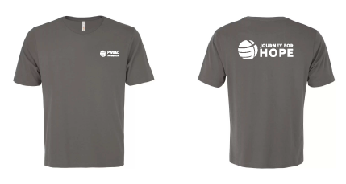
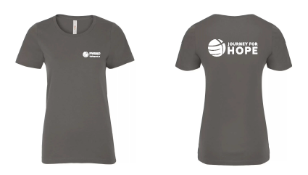
Standard Fitted

Sizes required: (Please write quantity required in boxes)
Size | Standard XS | Standard S | Standard M | Standard L | Standard XL | Standard 2XL
Quantity

Size* | Fitted S | Fitted M | Fitted L | Fitted XL | Fitted 2XL
Quantity
*Fitted shirts run small. We recommend sizing up one to two sizes.

If you have any questions, please contact Emma at egoldstein@presbyterian.ca
Thank you for representing PWS&D and the Journey for Hope!

