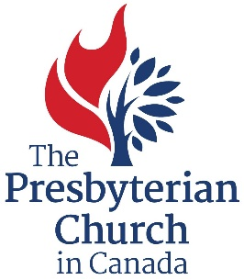

GOALS AND OBJECTIVES FORM

Setting goals provides critical feedback that tells you if the ministry is working effectively and how to improve it. Your goals and objectives can also explain what the church or ministry plans to do about a particular challenge or opportunity.

As part of the Supporting Ministry Grant application, each ministry is required to outline the minsitry’s goals and to identify 2-3 objectives for the forthcoming year. The purpose of this is to help ministries identify clear focal areas for the coming year, as well as set benchmarks to help track their progress.

NAME OF MINISTRY OR CONGREGATION
MINISTRY LEADER |  | PERIOD COVERED

MINISTRY DESCRIPTION
Who does the ministry serve? What needs in the community does it meet? Please provide a brief summary of the ministry and the community or group of people that are impacted by the ministry.

Please describe the ministry initiative that you would like to work on in the forthcoming year.

Please list the 2-3 specific objectives (results) that you are hoping to accomplish in the forthcoming year.

How will you achieve these objectives?

How will this impact the congregation or ministry?

RISKS AND ISSUES
What types of challenges are you facing?

ADDITIONAL INSIGHTS
How can we pray for the ministry? Are there any resources or assistance that we can provide to further support the ministry?

