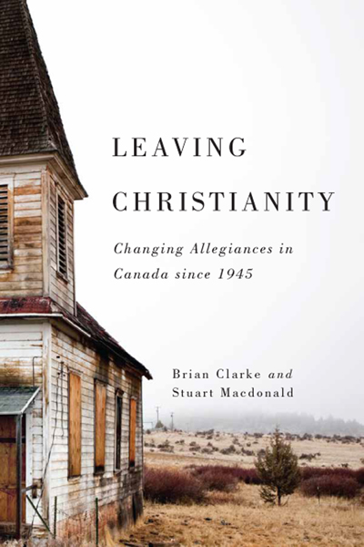

Brian Clarke & Stuart Macdonald. Leaving Christianity: Changing Allegiances in
Canada since 1945. Montreal/Kingston: McGill/Queens University Press, 2017.

“Decline in Christian affiliation, membership, and participation started in the 1960s and has picked up pace rapidly since then. This trend is likely to continue and, indeed, accelerate as an increasingly portion of the country’s population – among youth especially – have never been exposed to Christianity.” (p. 11)

“In short, Canadian society is entering into a new era, a post-Christian era. The end of Christendom, we will argue, occurred in the closing decades of the twentieth century, as churches lost their social power and their place in the nation’s cultural fabric.” (p. 11)

A quote from Rodney Stark in The Churching of America, “The churching of America was accomplished by aggressive churches committed to vivid otherworldliness….People tend to value religion on the basis of how costly it is to belong. The lower the value of belonging to it, and this eventually results in widespread defection.” (p. 19)

“In the Presbyterian Church in Canada, baptisms grew consistently from around 6,000 a year in 1945 to a peak of 11,380 in 1958, for an overall increase of 90%. The decline after this is quite sharp, and particularly so after 1965. The number of baptisms per year stabilized in the 1970s, and even recovered in the mid-1980s and early 1990s, before moving into a second period of major decline until they stood at just 1,710 in 2011, a drop of 85%.” (p. 49)

Commenting on Presbyterian, Anglican and United Churches, “By all these indications, change was sudden, it was broad based, it was massive in scale, and it gained momentum over time. It is no exaggeration to say that these churches for the most part lost the baby-boom generation. Not only did these churches lose baby boomers; they didn’t get them back, which accounts for the accelerated decline in membership as well as in baptism, Sunday School enrollment, and professions of faith or confirmation.” (p. 57)

“A recent study of large Canadian churches has discovered that there are an estimated fifty churches in Canada with weekly attendance over 2,000 and another 100 churches with weekly attendance over 1,000. While significant, this number is less than what one would have anticipated looking at the comparable figures in the United States. The United States has an estimated 7,000 Protestant church with an attendance over 1,000 or more, which would have led us to anticipate that the Canadian number, given we are one-tenth of the population, should have been closer to 700 not a mere 150.” (p. 100)

“When it comes to weekly attendance among all Canadians, those in the Atlantic region are most likely to attend weekly (rough a third in 1990), with attendance declining in Quebec and Ontario, followed by the West (at a fifth of the region’s population in 1990). ‘No Religion’ has had strong growth in the West, thereby shrinking the overall pool of Protestants, most of whom were among the less committed to begin with.” (p. 117)

“In 2011, some 7.7 million Canadians identified themselves as having “No Religion. No Religion is now the third-largest Census category after the categories “Catholic” and “Protestant.” Those who have No Religion outnumber the country’s largest Protestant denomination, the United Church of Canada, by a factor of almost 3.8. Not only are the numbers of those claiming No Religion large, but they represent a steadily increasing proportion of the Canadian population. In 1961 No Religion was 1%/in 2011 No Religion was 23.6%” (p. 163)

“Two major trends – today, for children under 15 in Canada often they have no parental religion to reject. Second, is that as Canadians age, a growing number who once identified as having a religious affiliation are choosing not to have one at all.” (p. 171)

“The distinction between being de-churched and non-church is a crucial one. The de-churched are those who at some point in their lives attended church but now no longer do so. The non-church have never attended except perhaps for a funeral or wedding of a friend or relation….To them Christianity is, in the words of the Church of England’s report Mission Shaped Church, ‘an utterly foreign culture.” (p. 171.)

“First, people are not only leaving churches; they are leaving Christianity. And many of them have no interest in returning. Second, an increasing and significant proportion of the population has never had any first-hand experience of organized religion.” (210)

Questions for Reflection:
- Which of the above quotes speaks most clearly to your congregation’s experience of the changing religious landscape in Canada? Why?
- Reflect and describe the ways in which you have observed the end of Christendom in your local church. What is the most painful part of that change for members of the church?
- What opportunities do you see in this new post-Christendom Canadian context? How might Christian witness thrive in this new post-Christian soil?

