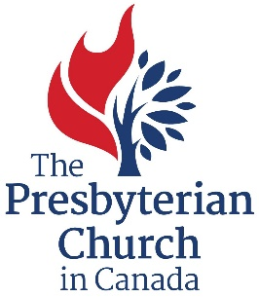

REQUIRED DOCUMENTS CHECK LIST

Grants through the Life and Mission Agency are only available to ministries that are under the oversight of a court of The Presbyterian Church in Canada. The ministry and presbytery consult to determine needs, clarify the focus of ministry, and ensure it fits within the presbytery’s current and future vision of mission and ministry.

Please ensure that all required documents have been assembled (forms and samples available from http://presbyterian.ca/canadian-ministries/supporting-ministry-grants/) as you prepare your application for a Supporting Ministry Grant.

Document Check List:
- Story of Mission (600 words or less, that tell a “story” of how God is working to transform lives in your community)
- Most recent annual report
- Goals and Objectives form (for the forthcoming year)
- Photos of the ministry (with photo release) – Ministries must submit a minimum of five individual photos that represent how the ministry is serving in the local community
- Financial statements including
  - Complete financial statement for the last full calendar year
  - Financial statements for current year (to-date)
  - Budget for the forthcoming year
- Annual Leading with Care report to presbytery
- Confirmation that current police records check for incumbant(s) is on file with the presbytery (ie. letter or email from clerk)
- Extract of presbytery minutes that endorses the application (ie. from clerk)
- Narrative description of ministry including the vision and detailed five-year financial plan (new applications only)

